Cervical HCP
Two linings meet at the cervix
The image should be outside of the ectocervix box.
Two linings, seen under the microscope
Separated the 2 images into each one of the boxes because each should be in the respective box.
Squamous metaplasia: the original and the new SCJ
“The everted columnar lining is exposed to the acidic vaginal environment.” and “
A new SCJ forms, where the new squamous epithelium meets the columnar lining.” should not be bold.
The transformation zone
The image should be outside of the Why it matters box.
HPV types, and what helps an infection persist
This should be a mind map. I changed it to image.
Rwanda compared with the region
“ASR per 100,000” should be “Cervical cancer incidence, age-standardised rate per 100,000 women, 2024” instead
Globocan source could be in a lower font size and not as it is showing as if it was a key insight
Where cervical cancer sits in Rwanda
“Estimated new cases” should be “Five most frequent cancers in women in Rwanda, estimated new cases, 2024”
Globocan source could be in a lower font size and not as it is showing as if it was a key insight
What is projected ahead
“New cancer cases a year” should be “All cancers in Rwanda: estimated and projected new cases a year”
Globocan source could be in a lower font size and not as it is showing as if it was a key insight
VIA step by step
“Identify the external os and the SCJ.” and “Hold cotton swabs soaked in acetic acid against the cervix, then wait 2 minutes.” and “Record the result, explain it to her, and agree the next step before she leaves.” should not be in bold.
Follow-up after an abnormal result
“Say plainly what the result is not: cancer has not been found.” and “Explain the next step, what it involves and roughly how long it takes.” and “Arrange it before she leaves, and record where and when.” and “Close the loop. Follow up actively if she does not attend.” should not be in bold.
Where cervical cancer care happens
Points2, 3 and 5 should not be in bold.
Counselling after a positive HPV test
Text should not be in bold.
Radiotherapy
The image should be outside of the Where it acts box.
Brachytherapy
The image should be outside of the Where it fits box.
Notes for French (all from English are applicable)

Session 1
When doing the question we get feedback of having (in my case) the wrong answer in English and also the “try again”. Should be in french
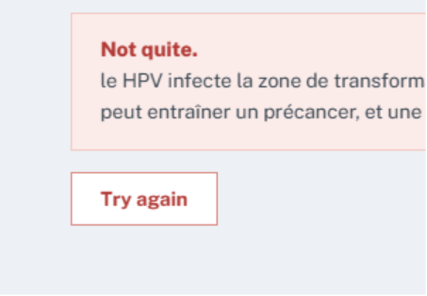
On the assessment you get
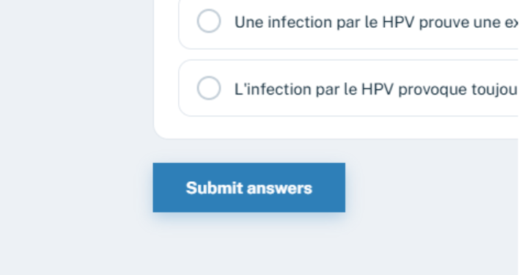
And after pressing that you also get the feedback in English and should be changed to french
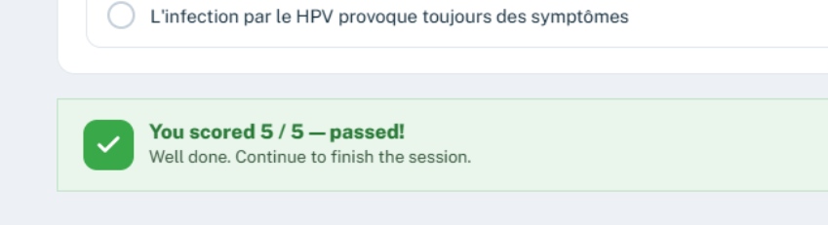

For session reflection also the same comment: there is still inconsistency in the language as there are headings with English
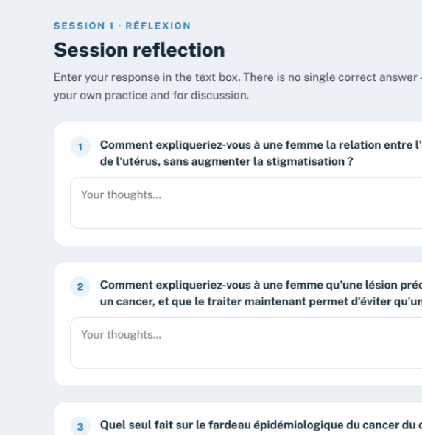

Session 2
On the video all the information should be in French so remove the “click to play”
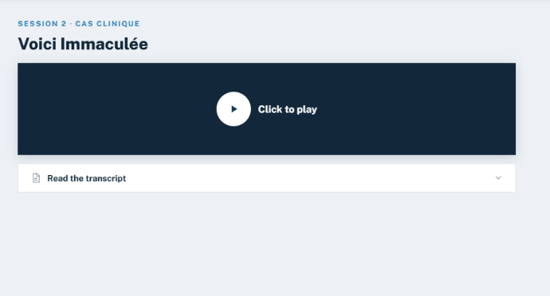

“required to continue” should be in French
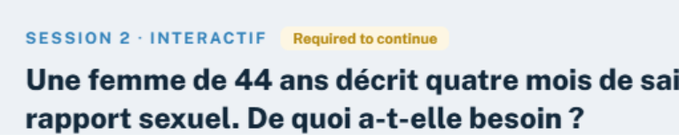

Change for French the “check my answers”
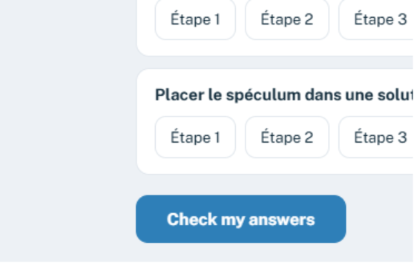
And then also for the feedback. I got a message in English saying “all match correctly” and should be in French
On this screen there are still places with info in English as “items to sort” or “check my answers”
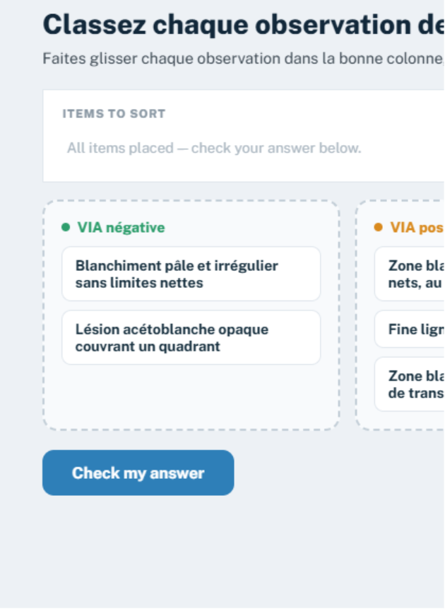

On the interactive assessment there is also info in English
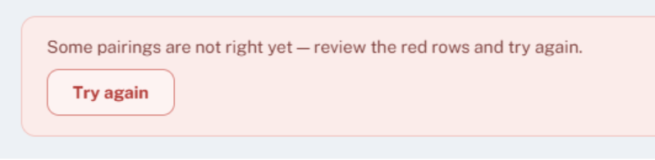
Also “check my answers” and then “all matched correctly”
On the next interactive test again the same info in English as “try again” , “all matched correctly” etc
On this screen the same comment I made in the English one: keep the format of the ppt as it was lost information here
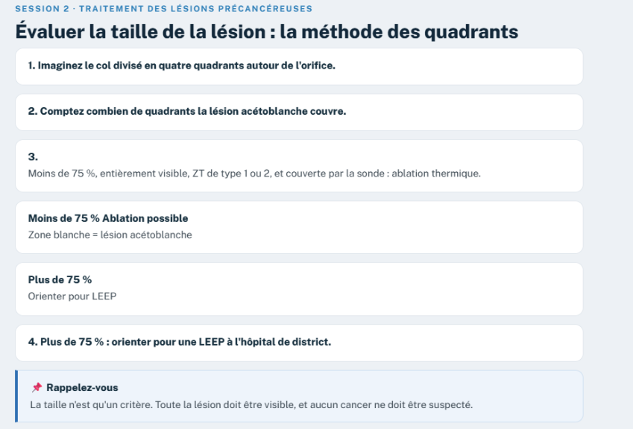
The video has information as “click to play” and “read the transcript”

On the knowledge check all information is in English on the header
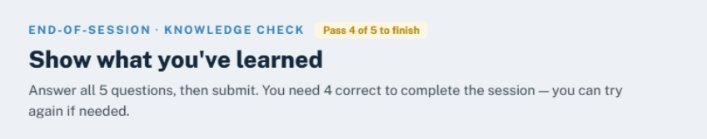

On section reflection there is inconsistency in the language as there are so many contents
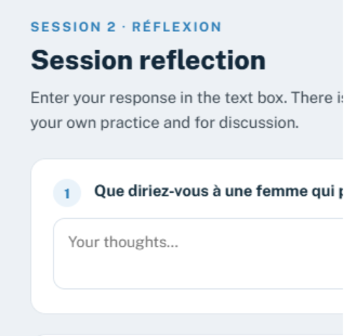

Session 3
The video has info as mentioned in the previous sessions “click to play”, “read the transcript”

In the knowledge check same comment as in the previous session (the header is in English)
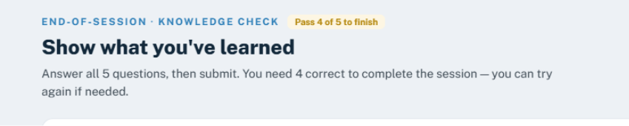

Session reflection also with header in English

Session 4
The header of “show what you have learnt” has to be in French
Session reflection has the same language inconsistency as mentioned before
Session 5
As in previous session there is inconsistency in language “check my answer” etc
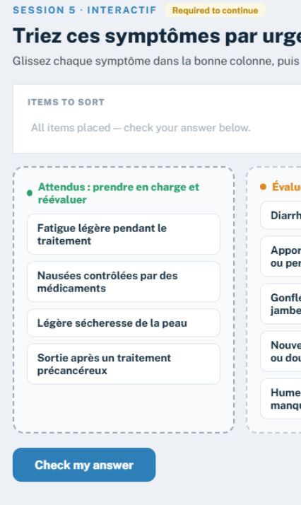

In here remove the bold so all text in the bullets looks the same
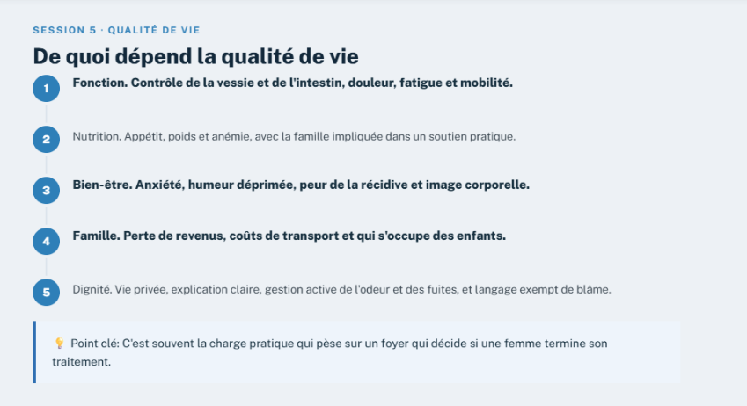

End of session, knowledge check (English as mentioned in the previous ones)

